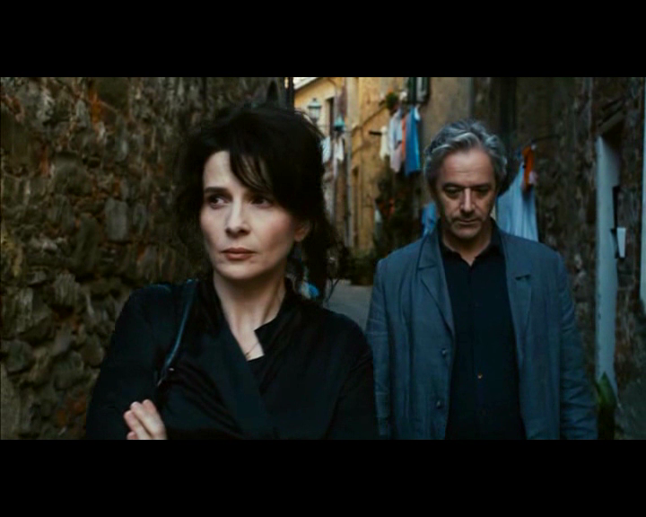

Figure 7: Literally tunneled in by their environment, Elle and James, visibly unhappy with each other, retreat into their own worlds.