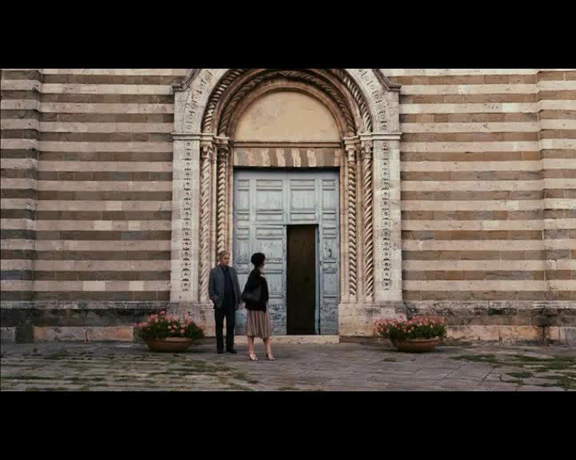

Figure 6: Here, the grandiose setting of a cathedral dwarfs the couple. Their lives and problems, from this perspective, seem small in respect to the wide world around them.