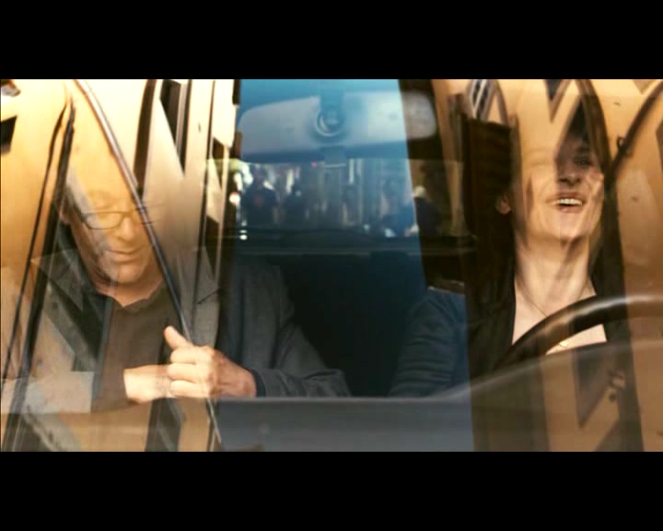

Figure : The use of color, reflection, movement, and light in this scene form a kind of palimpsest in which the couple are both literally and figuratively colored by their surroundings. The multi-layered effect creates a visual complexity which echoes the complexity of ideas presented by the plot.