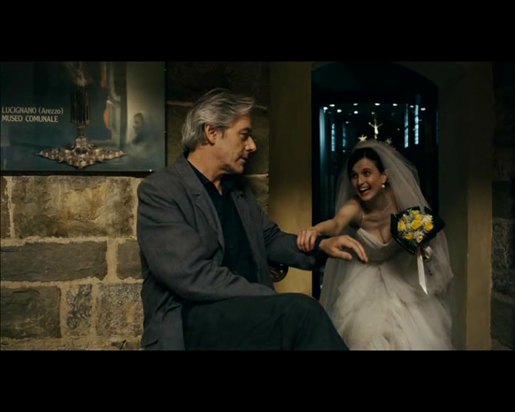

Figure 4: Here, James is once again visually blocked in by what he finds threatening—in this case, the institution of marriage, symbolized by the bride reaching out to pull him into the next room in order to take a photograph and by the mini-reflection of yet another bride in the framed poster just over his right shoulder.