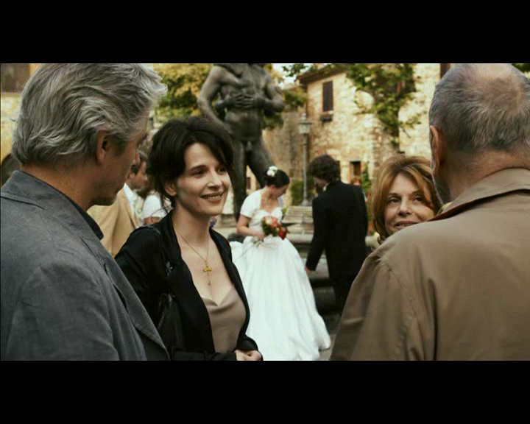

Figure : In this closed-form shot, we see three different types of couples: the couple starting out (the newlyweds in the background), the couple in mid-relationship crisis (Elle and James, on the left), and the slightly older, more experienced couple (the French tourists, on the right). The deliberate arrangement of this shot illustrates a familiar life cycle of relationships, each couple representing a different stage in the cycle.