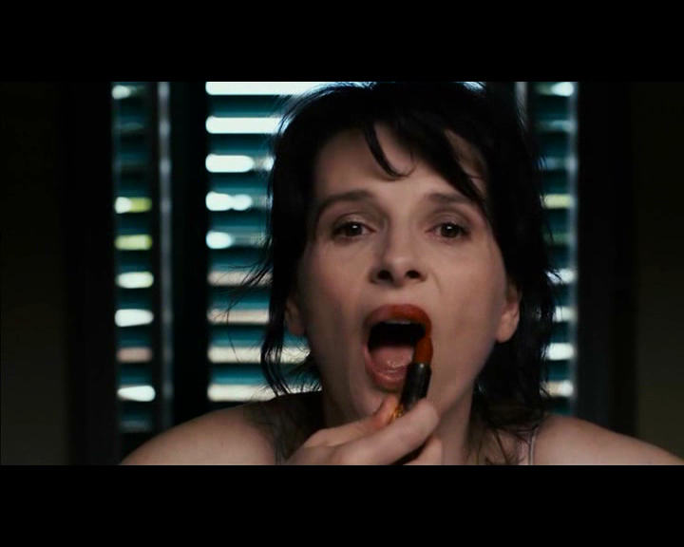

Figure : Framed by the window in the background, Elle applies lipstick while looking into the camera (a fictional mirror). It is unclear in this shot who is the object of the gaze—are we looking at her or vice versa?