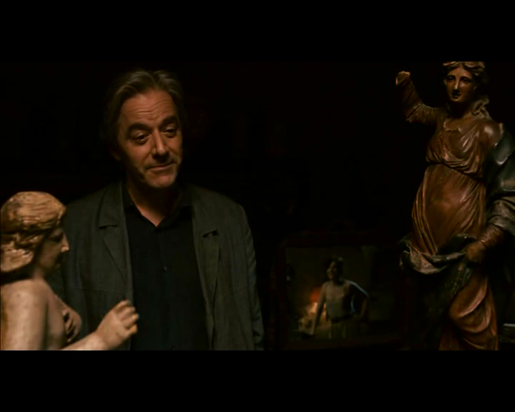

Figure : In this scene, set in Elle’s dark basement antique shop, James is tightly framed between the very objects he claims to keep his distance from—antiques. An interest in such antiques, he says, can be dangerous, and in this shot, he is literally boxed in by them, as is Elle. Here, he holds a conversation with Elle’s miniaturized reflection, reinforcing the idea that we may never really know a person, except through individual perspective. He does not and cannot see the real Elle, only a reflection of her.