KADIR HAS UNIVERSITY
cOMMUNICATION STUDIES ma
EDITING
How can we destroy actuality with editing?
THE THIN BLUE LINE
ÖZLEM TUĞÇE KAYMAZ
12/22/2011

Editing
How can we destroy reality with editing?
Before we begin to narrate or to show something we need to categorize it in order to explain it clearly. Film has the same principle. Narration needs the categorization of main ideas. In this way if we want to prove something or if we want to show something we must organize it. For this reason reality can change, because every categorization has a different perspective and every new narration has different point of view. In this paper I want to criticize that importance of editing in documentary cinema and I am going to use TheThin Blue Line which was directed by Errol Morris in 1988 as a case.
Editing has very important function to show reality or to change reality, because of categorization and order. Before the explanation of importance of editing I want to continue with the meaning of editing. Editing comes from the word –edit-. Edit mean the review of something or change of something. For this reason if editing comes from basis of edit, it can creates new meaning and new perspective.
According to Spence; “Editing is joining together of related shots and scene to make a sequence, and the joining together of related sequences to build the film” (161). In this sense editing makes film while it is gathering all information and materials together. For this reason it can change the reality of the real. Editing is one of most important piece of film making to narrate something. While organizing the film, editing helps for it, in this sense organize of something means that create a “new” idea. Directors’ choices from the parts of film creates a new meaning. How can they do this? How can they create a new idea? They are using editing, in this perspective editing is creation of a “truth”. They have their own truth, editing is reflection of it. In this sense we can say that editing creates new a point of view.

In fiction films editing is a major parts of the narration, and some role in documentaries However documentaries have power to make people believe. People want to believe documentaries, so order and editing effects this. Because audience have expectations about documentary, this expectation comes from belief. In this perspective editing can change their expectation; , it cannot change actuality but editing can change perspective of actuality. In this sense The Thin Blue Line is the creation of a new perspective of actuality. It is a documentary film on the other hand it is using fictional narration style to show actuality with editing in different point of view.
Importance of Editing
Editing is one of the most important aspects of cinema, because directors and scriptwriters need to narrate their ideas so they have to decide what is important? So that they need editing, but editing can be dangerous sometimes because if they do not use correct scene order, they will create a new idea which they do not want. Pudovkin and Eisenstein said that cinema won’t be an art without editing (Andrew, 177). This idea very important to understand how editing effects the cinema.
In cinematic narration or storytelling film needs some parts, such as, Performance, Event (cause-effect), Space , Editing , Mise-en-scene; Art Direction , Lighting, Cinematography, Sound and Music, these are main parts of filmic narration. Editing is part of these.However,. editing can destroy the actuality because order has a power to change meaning. So , while the director is choosing order of scenes, it is not a coincidence and these choices create new meaning.
In my opinion, editing helps to prepare the reality of filmic narration step by step to. Because viewer needs and wants to believe, editing helps viewers to believe which they need and want, this is their expectation. For this reason the editing of film have some principles to show reality or obliterate reality. According to Murch, ideal cut for fictional film editing has some principles , such as, it is true to the emotion of the moment, it advances the story, it occurs at a moment the is rhythmically interesting and “right”, it acknowledges what you might call “eye-trace” that is concern with the location and movement of the viewer’s focus of interest within the frame , it respects “planarity” which is grammar of three dimensions transposed by photography to two, and it respects the three dimensional continuity of the actual space (Sokolov, 2008: 45). These are parts of fictional film editing style, but all of them are parts of editing it means that they are used in documentary cinema, as well. In this sense The Thin Blue Line can use some parts of these roles. However, this film is documentary and these principles are used for the creation of fiction films; they are not reflects of actuality. TheThin Blue Line, however, is a documentary uses fictional narration style to manipulate actuality by using editing.

Editing for Documentary
Editing of documentary is different from fiction film’s editing because of flow. In fictional film editing, viewer accepts that this is fiction and wants to believe it. However in documentary film narration viewer accepts that this is a reflection of reality so that “I have to believe” this. Why ? Because documentaries are based on testimonies, footage, and evidences so viewer believes all items. How? Documentaries have some specialties, such as, voice over, evidence, reenactments, witness, old real videos, real recordings and photographs. These all prepare the viewer to believe. These are all a part of flow to narrate. For this reason people believe documentaries. And of course when the fact happened no viewer was there so they did not know what the reality happened, therefore they want to believe. Editing has very important role in this sense, because editing makes flow, creates thinking system of reality and makes point of order. In this point of view editing can reshape and manipulate material.
According to Spence, “All documentaries control the order in which information is given (…)” (Spence, 165) in this way documentaries can manipulate the actuality (“ reality”) like fiction films. Documentary films are different from fiction films because of the expectation of audience. Documentary film cannot contain all of reality but it can reflect of actuality, on the other hand fiction film reflects illusion and creates new world. In this sense editing is important to show actuality in documentary film, so that “order” is the most important idea because that it can change reality and create a new flow of reality.
This system is very important to understand how editing can manipulate or change the point of view and affect point of order. In this case, documentary editing must be different from fictional editing. However documentaries sometimes use this narration style, for example Hearts and Minds directed by Peter Davis in 1974. Film shows us Vietnam War and relations between people and American soldiers. War destroyed people’s lives and they could not do anything for their live. In the film American authorities, they defend their works, and they want to control the future of these people’s lives. They resist communism and they put pressure on Vietnamese people’s daily lives. In this case, editing is one of the most important mechanisms to narrate this history in a different perspective. Editor changed the order of scenes, and put different order under the voice over.
In classical film narration, voice over prepares viewer to follow the flow with editing. In Hearts and Minds, editing breaks the classical narration, it is creating new and affective and also dramatic narration style. While the soldiers were talking about bombs, under their voice over we see a significant amount of children’s images. They used powerful bombs on these people, children were the main victims of the bombings. They did not apologize for what they did they do, but viewer can understand what happened. So directors do not always need to tell what is happening, sometimes they only use images and editing to tell. For this reason I argue that editing is one of the most important aspects. It can be effective on the main them of the film, it can change the point of view.
This narration style destroys old classical film narration style. In this sense I want to continue with an example of “new” narration style, may be “new documentary” style which is used in The Thin Blue Line.
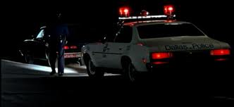
The “Thin” Blue “Line”
The Thin Blue Line, was directed by Errol Morris in 1988. The film is about investigation into the 1976 murder of Dallas police officer Robert Wood. Film deals with such concepts as, criminals, judges, police officers and witnesses. These all help to understand what is happening in the film. Initially we meet first Randall Adams (the accused), and David Harris (the accuser). After that we listened to local authorities on who is responsible for the crime.
Randall Adams ran out of gas and was picked up by a 16-year-old runaway-David Harris-. Later that night, they drank some beer, smoked some marijuana, and went to the movies. Adams claimed that he left for his motel, where he was staying with his brother, and went to sleep. Harris, however, said that they were stopped by police late that night, and Adams suddenly shot the officer approaching their car. At the beginning of the film a man is talking about something which happened, however we do not know who he is. This is not normal for classic documentary style, because director did not write introductory things about these people, such as Randall Adams and David Harris.
The Thin Blue Line does not use traditional narration style. In traditional narration the viewer is used to listening voice over and following the flow with voice over. However this film does not have any voice over. All parts continue without voice over and inducement. “with no voiceover commentary at all, it uses editing to guide the viewer’s interpretation so that rage can couple with the pleasure of knowing” (Spence, 177).
Director puts the viewer in labyrinth to find realty. This is a thin line to understand and follow the real reality. Because in this sense editing can manipulate it.
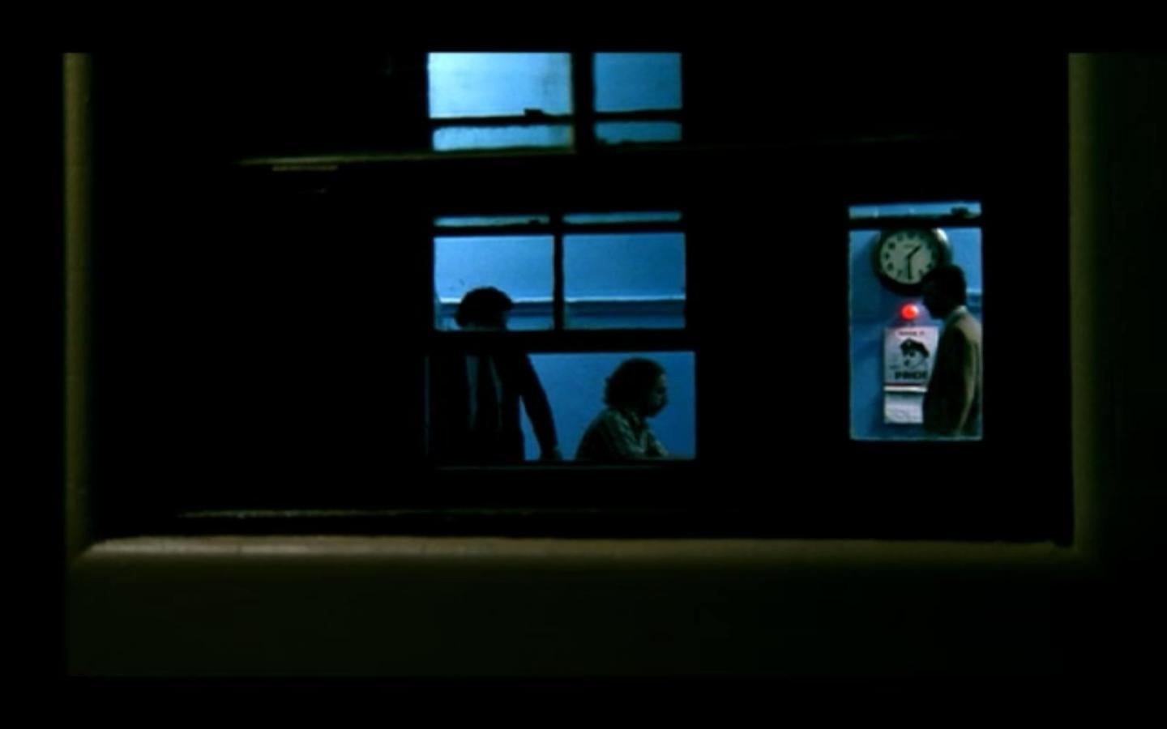
The film is different from traditional documentary cinema because of mise-en-scene. While director is narrating the story, he uses film noirish style, which is like an expressionist crime fiction. Film noir has some main features, such as crime, dark, contrasts, low-key lighting, shadows, chiaroscuro style, low angle, wide angle, dutch angle.Director is using this style in which the scenes are very dark, we never see a face of the police man who is shot, only a dark outline of his body, same with his partner. The scene that is reenacted over and over is the cop walking up to the car. Sometimes it’s the cop first getting out of the car, in an extreme long shot, establishing the position of both cars then walking over to the car, still in the long shot, and then there is the sound of gun shots. Other times the point of view is from the front of the suspect’s car, the outline of the driver and extreme close ups from the driver’s point of view, a long shot of the car driving away, leaving the body of the cop and the car. In other reenactments we often see a reflection of Adams in the car window.
The film is not only different from other films terms of mise-en-scene but also it is different in terms of a film editing. The film has reenactments, slow motions, fast motions, different lens uses, and different cutting system, etc. As Spence argues, “Some documentaries do try to minimize editing, using shots of long duration, sometimes shots that are whole scenes…”(Spence, 163) The Thin Blue Line differs because this film uses lots of fictional editing style. Some reenactments are like a part of fiction film. For example, police officer walks to the car again and again in different perspectives.
Another characteristic of the film is creation of editing. In fictional narration style editing is not felt by the viewer. However, in documentary narration style feel of the editing gives a trust that is reflection of reality. It means that, actuality created by editing agin in documentary.
In this perspective, editing is “invisible” in some parts of this film. This is a normal because, when the viewer does not feel editing in the documentary cinema, viewer will feel it can be a fiction. Directors “unitize techniques that make the cut invisible” (Spence, 166). For this reason invisible techniques make this film appear to be a fiction. This is a choice of a director because directors allows that to hear and see all versions of truth in addition to this truth is reflection of actuality in the documentaries so that viewer- audience- have expectation about documentary, this expectation comes from truth.
The film shows creation of reality with reenactments. Reenactments create different points of view, so in all reenactments a different perspective is created for the viewer. In this sense reenactments makes it possible to reflect new actualities. For instance, the police officer walks towards to the blue car four or three times again and again from different perspectives; this scene is showing that reality can be reflected from different points of view. This cannot be enough to change the reality but it can affect point of view of reality.
The reenactments recreate the testimony of each part in the police officer’s murder case. Using slow motion, reflections and creative framings Morris dramatically recalls details of witness’s explanations demonstrating the incompatibility between almost all the versions.
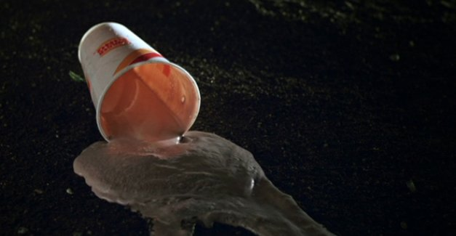
Especially slow motions are the most effective scenes in this film. For example, when the police man walked towards Adam’s car, female police was sitting in the car. When she hear shot of the gun, she threw away the milk shake from the car. In this screen milk shake fell down the street in slow motion. This is not a usual style of documentary narration. Because slow motion is mostly used in fictional film narration. For this reason, this documentary can be separated from other documentaries.
By editing the story in a way that reads like a modern crime dramas in TV shows for example Law and Order, director also gives the viewer a familiar flow that makes the story easier to engage. This is of course helped along by a score that helps to cue the viewer to read the film as a more than a documentary. However this is a documentary to show realty. Director shows how reality can be broken from editing.
As a result of all these, editing has one of the most important effects on narration; in this sense the director does not tell us the truth in his film, but with the aid of editing he allows us to hear all the versions of truth, and decide on our own. This film shows that reality can be manipulated in terms of the order of scenes in the editing process. .

Bibliography
- Louise Spence, Vinicius Navarro, 2011. Crafiting Truth: Documentary Form and Meaning., Rutgers University Press.

- J Dudley Andrew, 2007. Sinema Kuramı, Istabul: İzdüşümü.

- Jack Ellis. C, 2005. A new history of documentary film, New York: Contiunmm.

- John Berger, 1972. Ways of Seeing, London: Peguin Books.

- Aleksey G. Sokolov, 2008. Sinema ve Televizyonda Görüntü Kurgusu, Istabul: Agora Kitaplığı.

- Bernard, Sheila Curran, 2007. Documentary Storytelling, New York: Focal Press

- Bruzzi, Stella, 2008. New Documentary, Londan: Routledge

- Williams, Linda, 2009. Mirrors without Memories: Truth, History, and the New Documentarty, Film Quarterly, Vol. 46, no 3 ( Spring, 1993), pp.9-21

