Tables and Figures
Table 1: YouTuber Movies
YouTuber Movies

Films featured as the continuation of the YouTube channel
Directly YouTuber films
Films based on imaginative characters created on YouTube

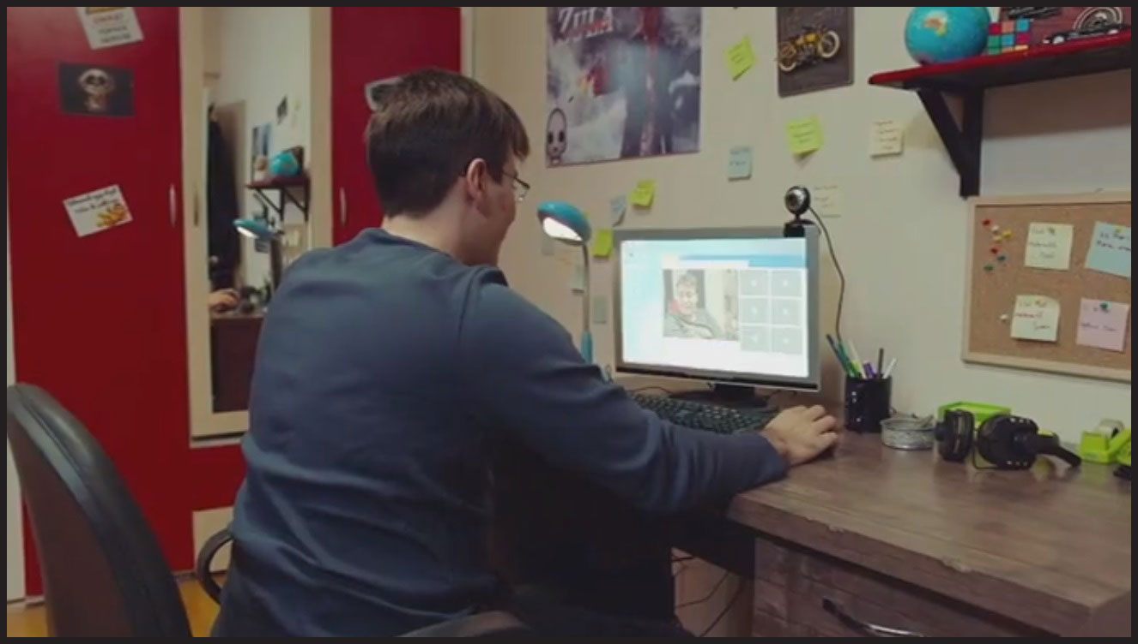
Figure 1: Enes Batur Hayal mi Gerçek mi? (2018)
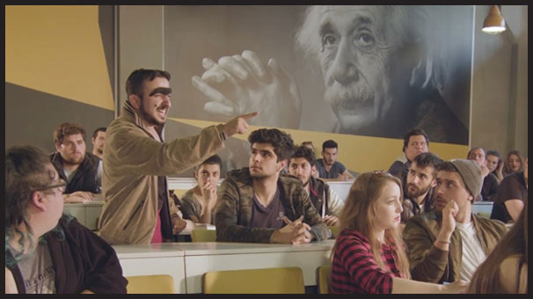
Figure 2: Cumali Ceber: Allah Seni Alsın (2017)
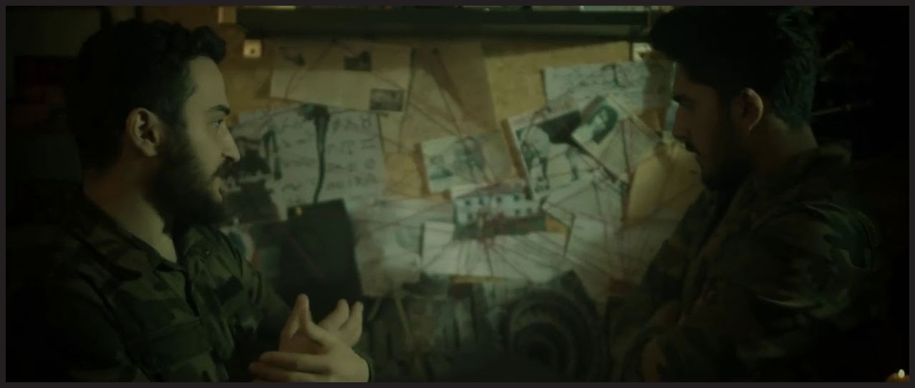
Figure 3: Kapalak Kızı (2018)

